## Problem 3 – Service Estimate

Create a Web page (HTML5 + CSS3 + images) that looks and behaves like the screenshots below:

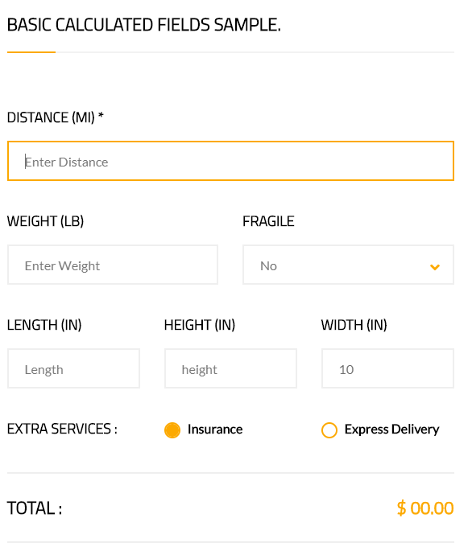

### Input

You are given the above screenshots + all required images + the texts on the site.

### Output

The output should be valid HTML5 + CSS3 + images that implement the above Web page.

### Constraints

* Use google font **Titillium Web** - <https://fonts.googleapis.com/css?family=Titillium+Web>
* Use google font **Lato** - <https://fonts.googleapis.com/css?family=Lato>
* The **shown focus effect** is **required**.
* The site should open correctly in the latest version of Chrome
* Pixel-perfect implementation is not required.